CWRU Bootcamp

Matplotlib Homework Observations Report – Goutham Polavaram

Observation 1: From the document notes, the four most promising regimens were: Capomulin, Ramicane, Infubinol, and Ceftamin. The box and whisker plots for the final tumor volume of each of these regimens were plotted. Since the maximum reduction of tumor size is the ideal outcome for any given regimen, from observation of the distribution, the Capomulin seemed to have the best results, followed by Ramicane. Both of these had a median final tumor size (38.123 mm3 and 36.56 mm3 respectively). Ramicane, has quartile ranges approximately equal distance from the median in comparison. However, the Capomulin had a lower quartile range much farther away from the median than its respective upper quartile range, one can make the assumption that the distribution skews to the left, meaning more of the test population for Capomulin lies under the median. **Capomulin would seem to be more effective compared to Ramicane due to the fact that more of the sample is skewed in a beneficial direction.**

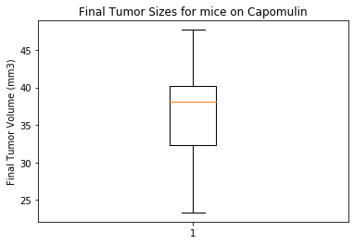 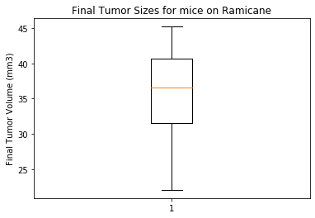

Observation 2:

From the notebook assignment to generate a line plot that graphs Tumor Volume vs. the Timepoint (days), the first mouse (alphabetically) was chose as **b128**. From the figure below, it is easy to see the clear trend that as time progresses, the **Tumor Volume has a distinct inversely proportional relationship**. More line plots would need to be run for the other mice in the Capomulin regimen to make a definitive conclusion, but from this graph, the relationship seems to be distinct and it warrants more study into the other Capomulin regimen.

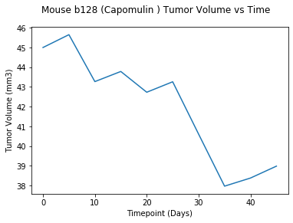

Observation 3:

**From the notebook assignment of graphing mouse weight vs average tumor volume (figure below), there seems to be a strong correlation based on the scatter plot graph and regression line**. 